2. Write a JavaScript for loop that will iterate from 0 to 15. For each iteration, it will check if the current number is odd or even, and display a message to the screen.    
   *Sample Output :*   
   "0 is even"   
   "1 is odd"   
   "2 is even"
3. Write a JavaScript program to set the background color of a paragraph.
4. Write a JavaScript program to calculate the volume of a sphere.  Sample Output of the form :

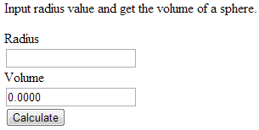

1. Write a JavaScript function to concatenates a given string n times (default is 1).  
   *Test Data* :  
   console.log(repeat('Ha!'));   
   console.log(repeat('Ha!',2));   
   console.log(repeat('Ha!',3));  
   "Ha!"   
   "Ha!Ha!"   
   "Ha!Ha!Ha!"
2. Write a JavaScript program to display the reading status (i.e. display book name, author name and reading status) of the following books.

var library = [

{

author: 'Bill Gates',

title: 'The Road Ahead',

readingStatus: true

},

{

author: 'Steve Jobs',

title: 'Walter Isaacson',

readingStatus: true

},

{

author: 'Suzanne Collins',

title: 'Mockingjay: The Final Book of The Hunger Games',

readingStatus: false

}];